INDEX
Sujeto: Pagina:
What is this? 3
What are these? 6
What is that? 7
What are those? 8
Repaso de la pronunciaciòn
de TH y WH 9
El verbo “To Be” 11
What color is …? 13
What time is it? 14
What day is it? 14
What month is it? 14
What is the date? 15
What season is it? 15
What is your name? 15

Who? 17
Whose? 17
When? 18
Where? 18
Why? 20
How? 20
How much? 20
How many ? 20

Is there? Are there? 20
Countries 21
Repaso de los pronombres 22
TIEMPO PRESENTE 23
Verbos communes 24
DO – DOES 29

copyright 2006 by Paul Rogers-derechos reservados - all rights reserved

PREGUNTANDO – CONTESTANDO
HABLANDO

WHAT IS THIS? (Uat iez dis)

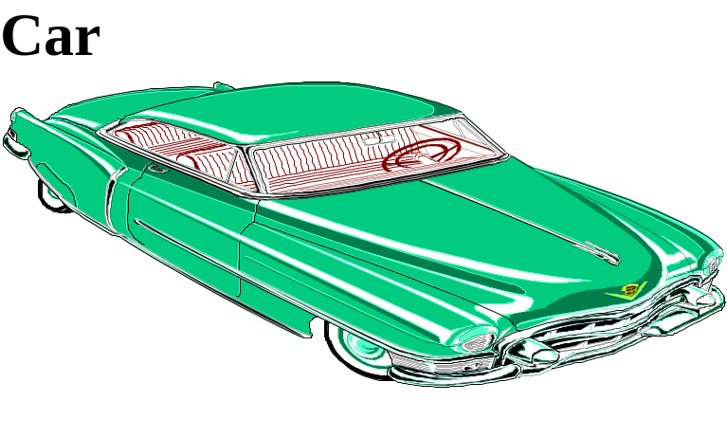What is this? This is a car.

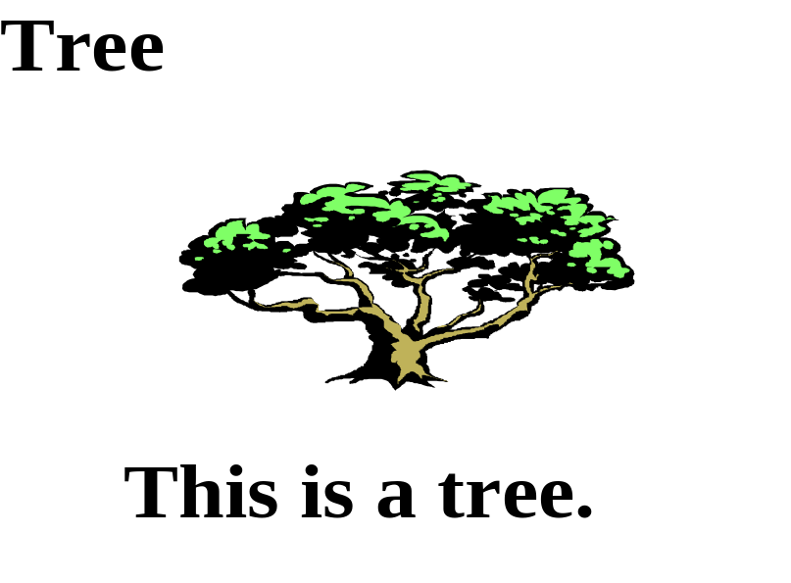What is this?

a con consonantes


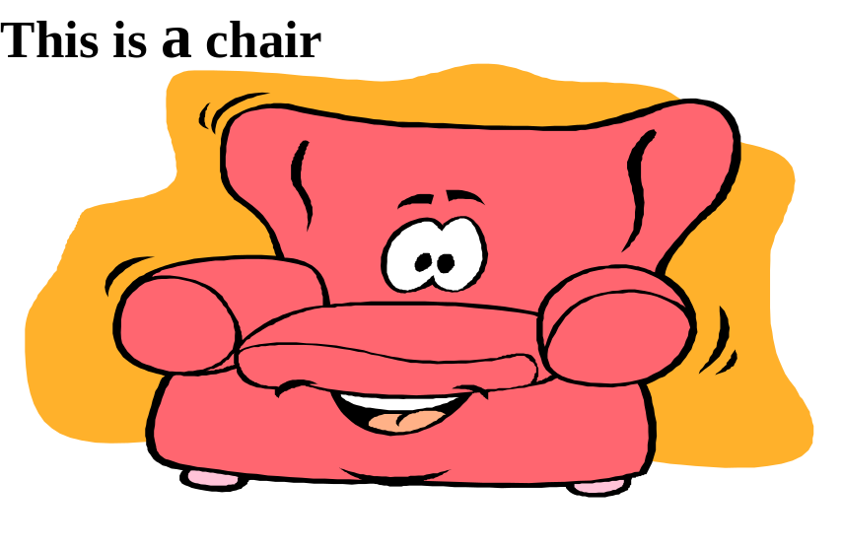

an = con vocales: a e i o u
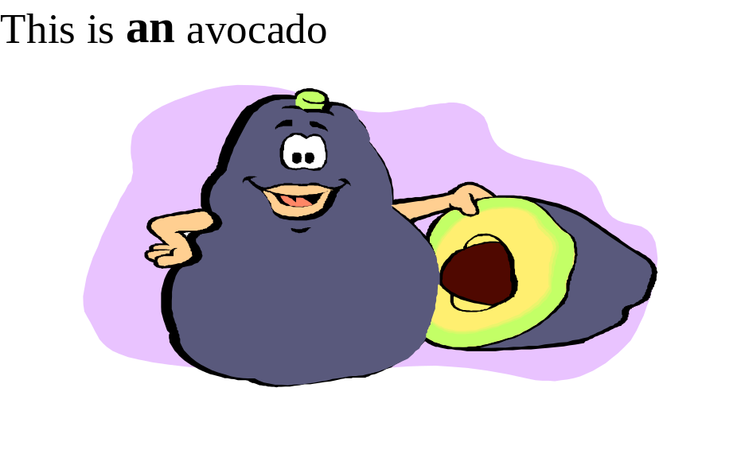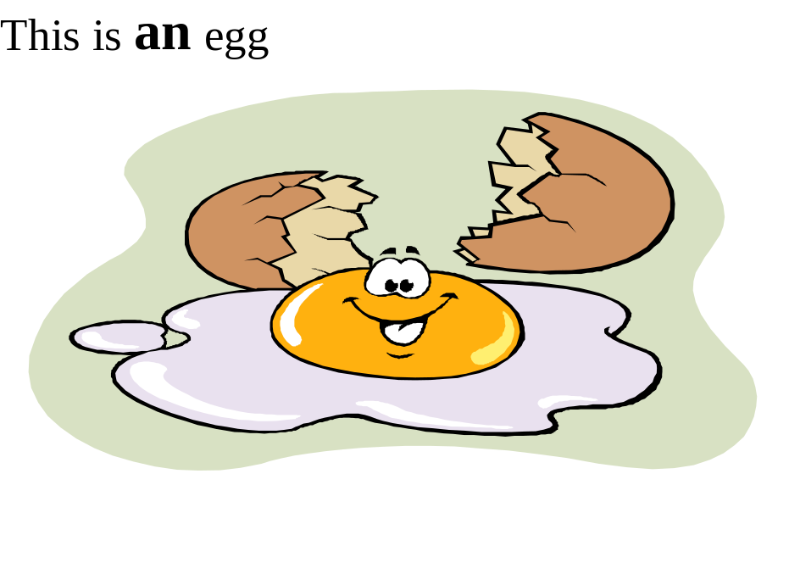

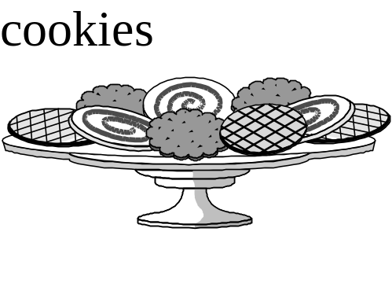What are these?

These are cookies.

What are these?


These are chiles.

What is that?


That is a book.

That is a door.

That is a window.

That is a house.

That is an apple.

That is an orange.

What are those? Aluminum cans
Those are aluminum cans.

What are those?

Those are bananas.

REPASO DE LA PRONUNCIACION
TH - La pronunciación de “th” se hace asi: sague la lengua y ponla en los dientes de arriba y sopla! No se pronuncia como ‘T’ ! -

Con vibración -
the (tha) - el, la
other (ath-ir) - otro
that (thaet) - ese
this (thies) - este, esta
they (thei) - ellos
there (their) - alli, alla
their (their, tambien!) - de ellos
therefore (their-for) - por eso

Sin vibración -
three (thri) - tres
thirteen (thier-tin) - trece
thirty (thir-ti) - treinte
thirsty (thiers-ti) - sediento
thin (thien) - flaco
think (thienk) - pensar
thumb (tham) - pulgar
Thursday (thiers-dei) - jueves

WH - tiene dos sonidos:

1. Quita la h, la mayoría -
what (iuat) - que
when (iuan) - cuando
where (iuer) - donde
why (iuai) – porque

2. quita la W -
whole (jol) - entero

who (ju) - quién
Who

EL VERBO TO BE (ser y estar)

Inglès no distingue entre los verbos ser y estar. Los dos traducen a TO BE.
La palabra “to” en frente un verbo significa la forma infinitivo.

español inglès
SER / ESTAR TO BE (tu bi)

SINGULAR
yo soy / estoy I AM (ai am)

tu eres / estàs YOU ARE (iu ar)

el es / està
HE IS (ji es)

ella es / està SHE IS (shi es)

el o ella es / està (cosa) IT IS (iet is)

PLURAL
nosotros somos / estamos WE ARE (ui ar)

Uds. son / estàn YOU ARE (iu ar)

ellos son / estàn THEY ARE (thei ar)

ellas son / estàn THEY ARE (thei ar)

What color is ….?

What color is an apple? An apple is red.
What color is an orange? ______________.

What color is a chile? ________________.

What color is a rose? __________________.

What color is a banana? ___________________.

What color is the sun? (SOL) The sun is yellow.
What color is the sky? (CIELO) The sky is blue.
What color is the flag? (BANDERA)
Red, white and blue.

The – el, la, los, las

What time is it?
It is …

Do you know what time it is?
(“Do” y “Does” hacen preguntas)
Yes, it is 5 O’clock.
What time is the class? The class is at 6 O’clock.
What time does the class start?
The class starts at 6 O’clock.
What time does the class end?
The class ends at 8 O’clock.

What day is it?
Monday, Tuesday, Wednesday, Thursday,
Friday, Saturday, Sunday.

What day is it today? Today is Thursday.
What day is the class? The class is on Tuesday and Thursday.

What month is it?
January, February, March,
April, May, June, July, August,
September, October, November, December.

What month is it?
It is September.

What is the date?
It’s Thursday, September 8th.

What is your date of birth?
My birthday is January 11th, 1944.

What season is it?
Summer, Fall, Winter, Spring.
It is fall.
Fall is also called autumn.

What is your name?
My name is …

What is your mother’s name?
My mother’s name is Ann.
What is her name?
Her name is Ann.

What is your father’s name?
My father’s name is Sam.
What is his name?
His name is Sam.

What is the teacher’s name?
The teacher’s name is Paul Rogers.

El apostrofo - (la marka - ' -) - aveces significa que la palabra es una combinaciòn de dos palabras y ya falta una letra.
Nota - aveces el apostrofo significa posesiòn, como "Pedro's hat = el sombrero del Pedro)

WHO
Who am I? I am a teacher.
Who are you? You are a student.
Who is he? He is a mechanic.
Who is she? She is a cook.
Who are they? They are students.
Who is = Who’s
Who is your father? = Who’s your father.

Who is that?
That is the Jones Family.
Martha is the mother, Sam is the father,
Sally is the daughter, and Jim is the son.
Who is the mother? Martha is the mother.
Who is the father? Sam is the father.

Who is your father? Who is your mother?
Who is your uncle? Who is your aunt?

WHOSE – de quien
Whose book is this? This book is my book.
Whose car is that? That car is my car.

WHEN
When is the class? The Class is at 6 O’Clock.
When is your birthday? My birthday is January 11th.
When is the party? Next Saturday

WHERE
Where is the English Class? In room 43.
Where is the party? At Mary’s house.
Where are the sodas? In the refrigerator.

Where do you live?
I live in Oxnard.

Do you live in Texas?
No, I live in California.
What city do you live in?
I live in Ventura.

What is your address?
My address is 444 B St., Oxnard.
Where is Oxnard?
Oxnard is in Southern California,
about 100 miles north of Los Angeles.

Where were you born?
I was born in Melrose, Massachusetts, USA.

Where are you from?
I am from Massachusetts.

WHY
Why is the class cancelled?
Because the teacher is sick.

HOW
How are you? I’m fine.
How do you spell your name?
How do you pronounce refrigerator?

HOW MUCH
How much is five and seven? 5 and 7 is 12.
How much does the soda cost?

HOW MANY
How many students are in the class?
There are 25 students in the class.

Is there? ¿HAY?
Are there? ¿HAY?

COUNTRIES
India, Africa, China
Europe, Russia, Germany
Mexico, Japan

What is your country?
My country is _______.

Cities
Los Angeles, Madrid, Tijuana, La Paz

Where is Los Angeles?
Los Angeles is in California.
Los Angeles is in Southern California.

Where is Tijuana?
Tijuana is in Mexico.
Tijuana is in Northern Mexico.
Tijuana is in Baja California, Mexico.

Is that Los Angeles? Yes, it is.
Is that Tijuana? No it isn’t.
It is Rosarito.
Rosarito is south of Tijuana.

REPASO
PRONOMBRES - PRONOUNS

Un pronombre es una palabra que se usa en vez del nombre de un sustantivo (persona, cosa o lugar).
Nota: En inglès siempre tiene que usar pronombres o nombres con el verbo.

SINGULAR
español : inglès: (pronunciaciòn)
yo I (ai)
tu YOU (iu)
usted YOU (iu)
el HE (ji)
ella SHE (shi)
el o ella (para cosa) IT (iet)

PLURAL
nosotros WE (ui)
ustedes YOU (iu)
ellos, ellas THEY (thei)
y cosas

TIEMPO PRESENTE DE LOS VERBOS
La reglas de la S

Persona: Singular: Plural:

1ª I talk We talk

2ª You talk You talk

3a He talks They talk
She talks
It talks

Excepciones-
Can, could, may, might,
would, should, will, had

Verbos comunes:

DO Y DOES
I DO
YOU DO

HE
SHE …….. DOES
IT

WE
YOU …….DO
THEY
_________________________________________
HAVE
I HAVE
YOU HAVE

HE
SHE …. HAS
IT

WE
YOU ….HAVE
THEY

Verbos comunes:

To have – tener y haber

Tener
Presente: Today I have a million dollars.
Pasado: Yesterday I had five dollars.
Futuro: Tomorrow I will have no money.

You have a red car.
Yesterday you had a blue car.
Tomorrow you will have a green car.

He has a big house.
He had a small house yesterday.
Tomorrow he will have no house.

We have no water.
They have the water.
You plural have a good teacher.

Haber
I have learned Spanish.
I have listened to the CD.
You have learned English.
He has learned English.
She has learned English.

TO BE
I am a teacher.
You are a student.
He is a carpenter.
We, you, they … are

I was a taxi driver a long time ago.
You were not in class yesterday.
She was not here yesterday.
We, you, they …were

Can
I can play the piano.
You can not play here.
She can speak German.

Want
I want a million dollars.
She wants a new car.

Like
I like hot dogs.
He likes baseball.
We like English class.

Play
I play the violin.
She plays the piano.
He plays baseball.

Earn
I earn $100 in my job.
You can earn $50.
She wants to earn $400.

Cost
A new car costs a lot of money.
Bananas cost $1 a pound.

Spend
I spend my money in the store.
You can spend a lot of money in the supermarket.

Pay
I pay $5 for the movies.
You pay $3 for gas.

Go
I go to school.
He goes to the store.

Come
I come from Alabama.
You come from Rosarito.
She comes from Tijuana.

Live
I live in California.
He lives in Mexico.

Make
I make my bed in the morning.
He makes too much noise!!!

DO o DOES?
DO = I, you (singular), we, they
DOES = he, she, it, and names of people and places
DO Y DOES
Traduzca:

1. What do you do?

2. Where do you live?

3. Where does your family live?

4. What does your ________(father, mother, sister, brother) do for work?

5. When does the English class begin?

6. What does “estudiante” mean in English?

7. Why do you like to study English?

8. Does your friend like to study English too?

9. What does your friend do?

10. Where does your friend live?

11. Where do the students study English?

12. Why do they study English?

13. When does the class start?

14. Who does the cooking in the restaurant?

15. When do we eat lunch?

16. How do you like to cook your hamburger?

17. How does the teacher pronounce “refrigerator”?

18. Where do we go for lunch?

19. Why do we use “DO” and ‘DOES”?

20. When do you do your homework for English class?

21. Who are you going to vote for?

22. When does the train arrive?

23. How do you pronounce "refrigerator"?

24. How do you say your name?

25. Where do they go for lunch?

Aprende Inglés - por INTERNET

WWW.PUMAROSA.COM ***GRATIS
NUEVO - CD rom de website
¡El método de Pumarosa es muy sencillo!
¡Solo súbele a tus bocinas y a aprender inglés se ha dicho!
Principiante ("Beginner") y Indtermedio - INTERACTIVO CON VOZ+

CLASES – LIBROS – CDs
Profe. Paul Rogers, B.A., Lic., 619-429-7973
Pumarosa21@yahoo.com

